Homework 4: Morphological Image processing

# Hit-or-Miss Method

## Binarization

Binarize the two test images using Otsu’s segmentation in Matlab (graythresh). Choose the threshold by applying Otsu’s method to the clean images, and then use the same threshold for remaining images.

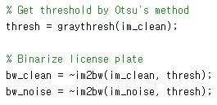

## Perform the character recognition using a simple erosion operation

Step 1: Apply the erosion to the binarized template image (SE: 3x3 square)

Step 2: Apply the erosion to the binarized clean and noisy plate images (SE: the eroded template image from step 1)

Step3: Apply the dilation to detected result (SE: eroded template image from step 1) , and then overlay it on the binarized image

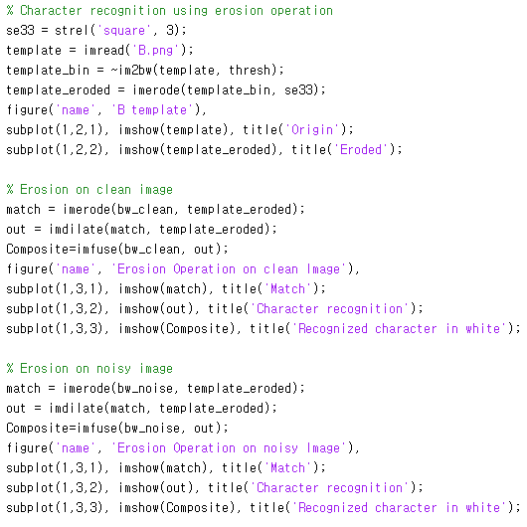

## Perform the character recognition using a hit-or-miss method

Step 1: Apply the erosion to the binarized template image (SE: 3x3 square).

Step 2:

SE1: the eroded template image from step 1

SE2: the dilated template image using 5x5 square – the dilated template image using 3x3 square.

Step 3: Apply the dilation to detected result (SE: eroded template image from step 1), and overlay it on the binarized image.

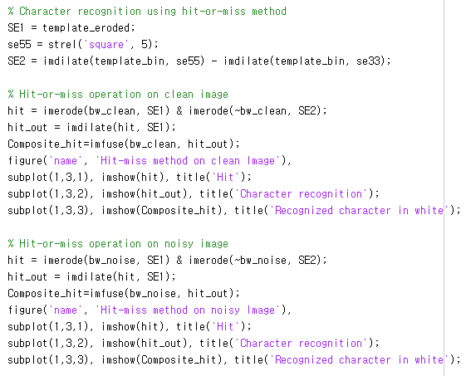

## Perform the character recognition using a rank filter in Matlab (use ‘ordfilt2’)

Hit_point = min(ordfilt2(image, p1, SE1), ordfilt2(~image, p2, SE2)).

Choose appropriate p1 and p2 that produce correct detection results in the noisy plate image

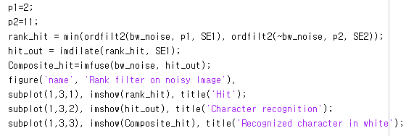

## Results

### Binarize the two test images using Otsu’s segmentation method.

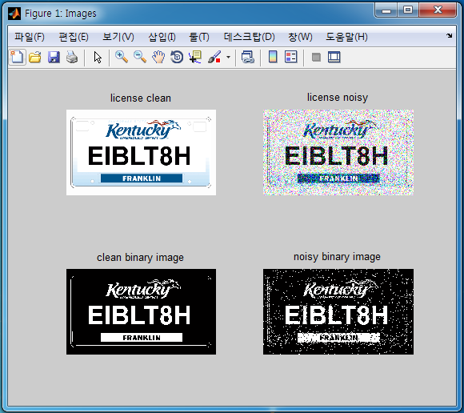

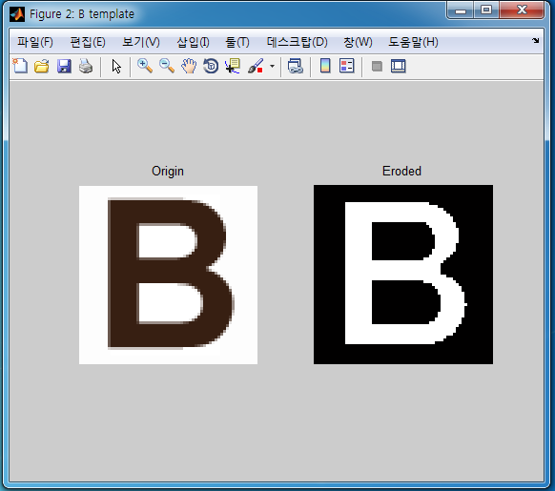

### Perform the character recognition suing a simple erosion operation.

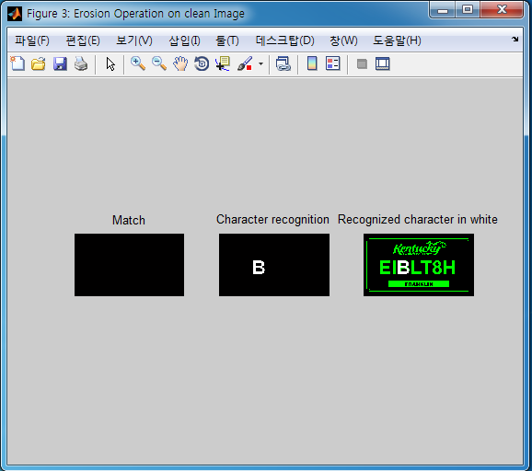

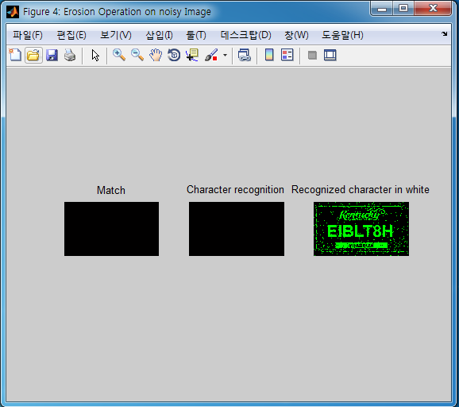

### Perform the character recognition using a hit-or-miss method.

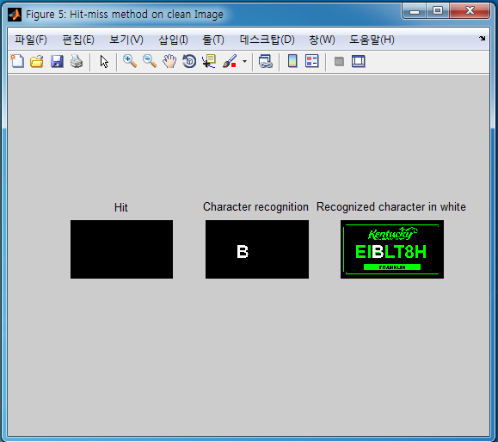

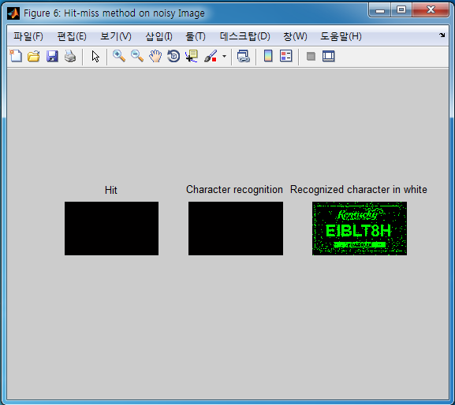

Applying erosion operation or hit-or-miss method on noisy image, we get the same result that we cannot recognize the character from noisy image if use either methods.

### Perform the character recognition using a rank filter.

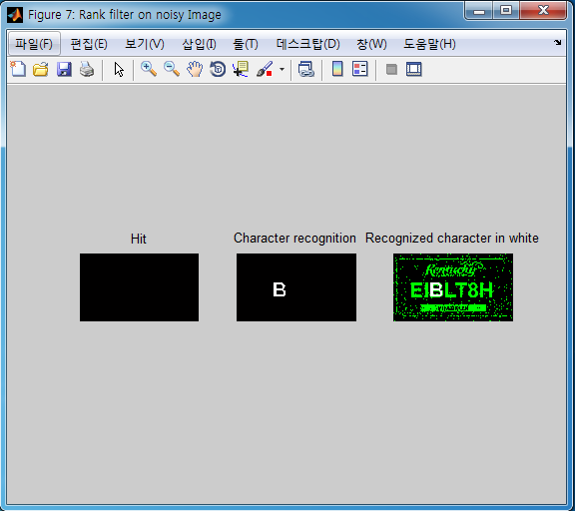

# Dilation and Erosion

## Implementation

Enhance a blurry image by sequentially applying the dilation and erosion. A structuring element (SE) can be designed in a way of producing the best performance. The procedure is as follow:

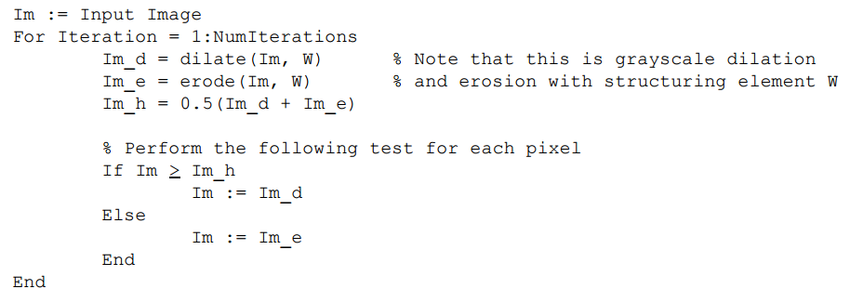

Design structuring element:



Enhance the blurry image bases on the procedure above and plot intensity profile for each iteration

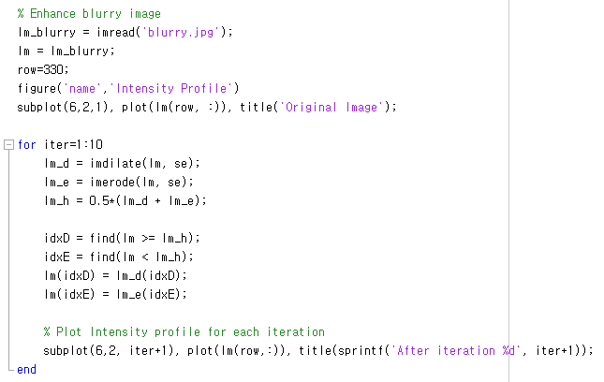

## Results

### Intensity profile for each iteration

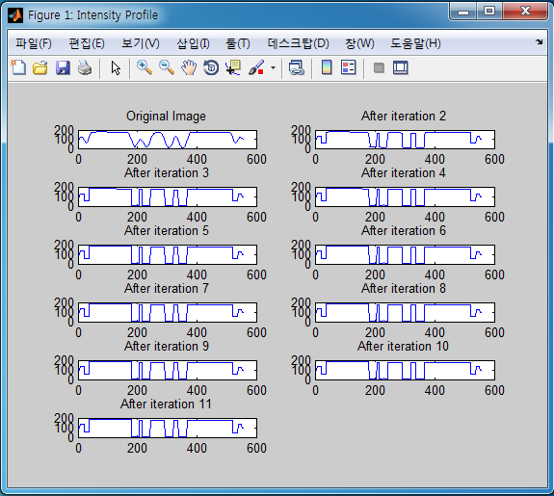

From intensity profiles above, we can see that the valleys which in ‘v’ shape according to blurred parts in the image have been enhanced to become ‘u’ shape according to step edges in the image.

### Enhanced blurry image

